Junit Testing

**Authentication:**

Testing the logIn method

**Test1:**

Testing connection to the database

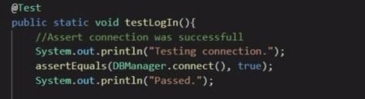

This Test Passed, in addition I tested if you could connect to the database without an internet connection. Program was run disconnected from the internet and as expected could not connect

**Test2:**

Testing a Invalid login and password combination will return a null user



This test passed, when a user in not connected or a login and password combination that is not saved in the database is input then a Null user will be returned

**Test3:**

Testing a valid login and password combination

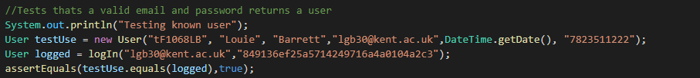

This test passed, when a user already exists the information is compared against the database and any valid usernames and passwords are allowed access to the system.



**Registration**

Testing the Registration method

**Test1:**

Testing connection to the database

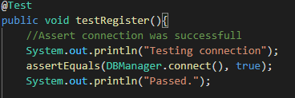

**Test2:**

Testing that an existing user cannot be registered

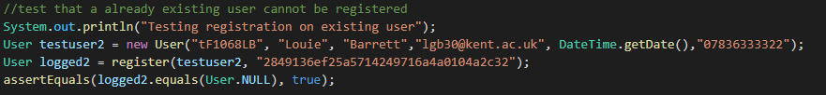

This test passed, when a existing user is passed to the result set if there is already a existing user with these same details then a user.null will be returned

**Test3:**

Testing that registering a new user creates a new user

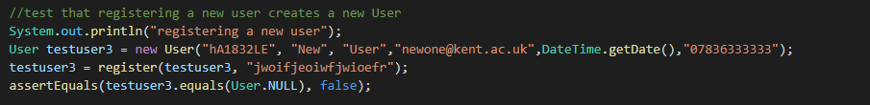

This test Passed,when a new user and password are passed through the register method it checks to see if it exists in the result set and if it does not then the user will be added to the database via the insertUser method,

